**TEIGNMOUTH HARBOUR COMMISSION LOCAL NOTICE TO MARINERS 6/22**

**Unmanned Surface Vessel Operation**

Date of issue: 10 Aug 22

All mariners are advised there will be an Unmanned Surface Vessel (USV) (Fig1) operating in the vicinity of Coombe Cellars (Fig 2) periodically between Thu 11 Aug – 30Sep.

The HydroSurv Unmanned Ingenuity Vessel will be operated from ashore and will have a support RIB in attendance. During the trials; all vessels are advised to take particular care, passing at a safe distance, no more than 6 knots speed and minimal wash.

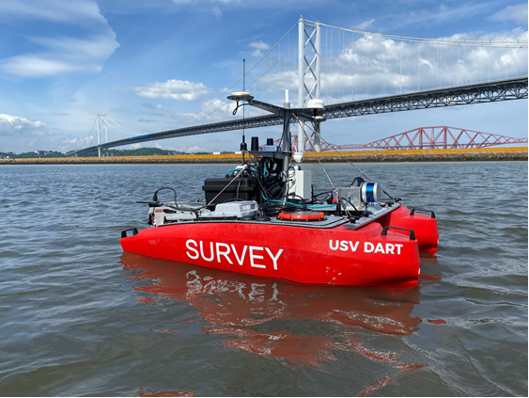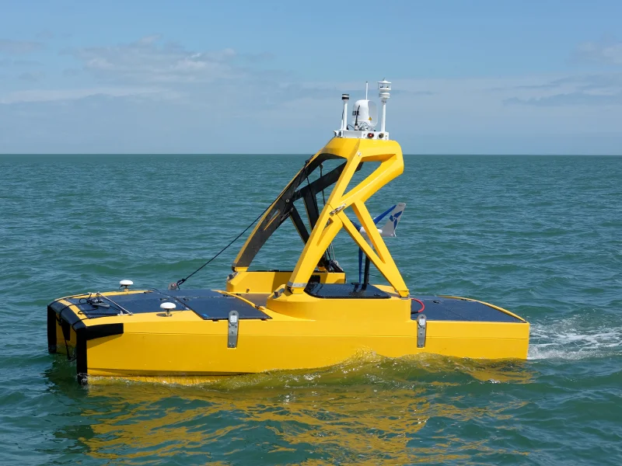

Fig 1. Examples of USVs

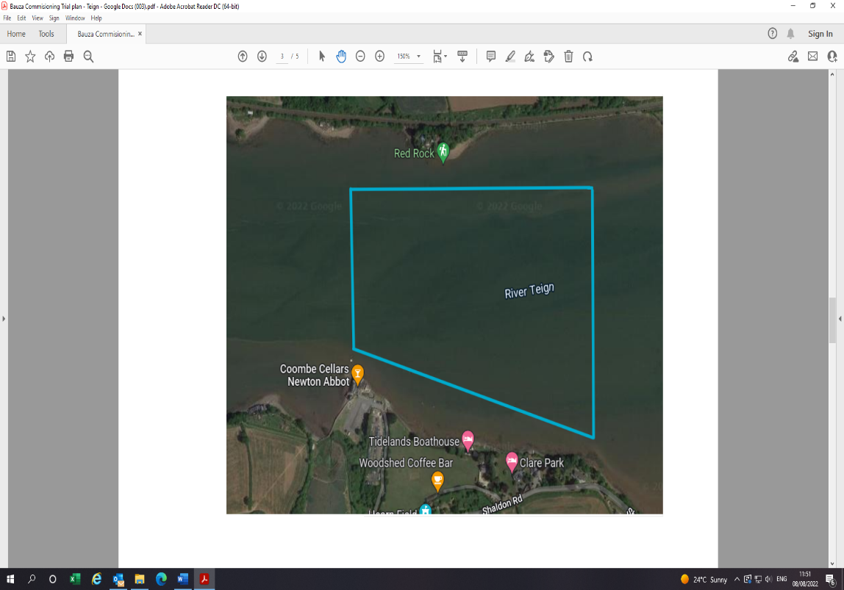

For further information please contact the Harbour Office on +44 (0)1626 773165 M-F 0900-1600, VHF Channel 12 or the Duty Mobile number on 07943 722029outside these times.

We thank you for your cooperation and support.

Fig 2. Area of Operation.

*Karen*

Captain Karen Dalton-Fyfe

Chief Executive and Harbour Master

Teignmouth Harbour Commission

Harbour Master ABP, Teignmouth and Millbay

[www.teignmouthharbour.com](http://www.teignmouthharbour.com)